**Data Warehousing - OLAP**

Online Analytical Processing Server (OLAP) is based on the multidimensional data model. It allows managers, and analysts to get an insight of the information through fast, consistent, and interactive access to information. This chapter cover the types of OLAP, operations on OLAP, difference between OLAP, and statistical databases and OLTP.

**Types of OLAP Servers**

We have four types of OLAP servers:

* Relational OLAP (ROLAP)
* Multidimensional OLAP (MOLAP)
* Hybrid OLAP (HOLAP)
* Specialized SQL Servers

**Relational OLAP**

ROLAP servers are placed between relational back-end server and client front-end tools. To store and manage warehouse data, ROLAP uses relational or extended-relational DBMS.

ROLAP includes the following:

* Implementation of aggregation navigation logic.
* Optimization for each DBMS back end.
* Additional tools and services.

**Multidimensional OLAP**

MOLAP uses array-based multidimensional storage engines for multidimensional views of data. With multidimensional data stores, the storage utilization may be low if the data set is sparse. Therefore, many MOLAP server use two levels of data storage representation to handle dense and sparse data sets.

**Hybrid OLAP (HOLAP)**

Hybrid OLAP is a combination of both ROLAP and MOLAP. It offers higher scalability of ROLAP and faster computation of MOLAP. HOLAP servers allows to store the large data volumes of detailed information. The aggregations are stored separately in MOLAP store.

**Specialized SQL Servers**

Specialized SQL servers provide advanced query language and query processing support for SQL queries over star and snowflake schemas in a read-only environment.

**OLAP Operations**

Since OLAP servers are based on multidimensional view of data, we will discuss OLAP operations in multidimensional data.

Here is the list of OLAP operations:

* Roll-up
* Drill-down
* Slice and dice
* Pivot (rotate)

**Roll-up**

Roll-up performs aggregation on a data cube in any of the following ways:

* By climbing up a concept hierarchy for a dimension
* By dimension reduction

The following diagram illustrates how roll-up works.

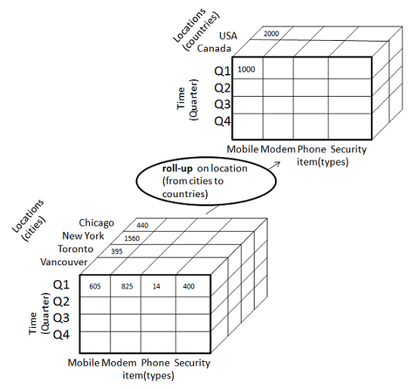

* Roll-up is performed by climbing up a concept hierarchy for the dimension location.
* Initially the concept hierarchy was "street < city < province < country".
* On rolling up, the data is aggregated by ascending the location hierarchy from the level of city to the level of country.
* The data is grouped into cities rather than countries.
* When roll-up is performed, one or more dimensions from the data cube are removed.

**Drill-down**

Drill-down is the reverse operation of roll-up. It is performed by either of the following ways:

* By stepping down a concept hierarchy for a dimension
* By introducing a new dimension.

The following diagram illustrates how drill-down works:

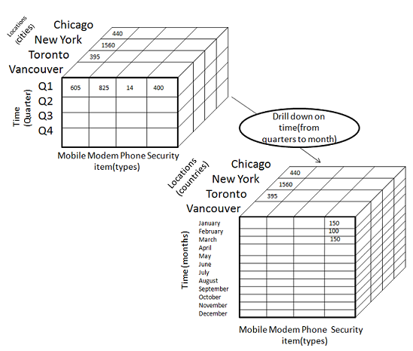

* Drill-down is performed by stepping down a concept hierarchy for the dimension time.
* Initially the concept hierarchy was "day < month < quarter < year."
* On drilling down, the time dimension is descended from the level of quarter to the level of month.
* When drill-down is performed, one or more dimensions from the data cube are added.
* It navigates the data from less detailed data to highly detailed data.

**Slice**

The slice operation selects one particular dimension from a given cube and provides a new sub-cube. Consider the following diagram that shows how slice works.

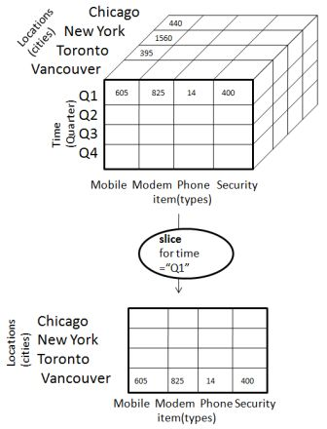

* Here Slice is performed for the dimension "time" using the criterion time = "Q1".
* It will form a new sub-cube by selecting one or more dimensions.

**Dice**

Dice selects two or more dimensions from a given cube and provides a new sub-cube. Consider the following diagram that shows the dice operation.

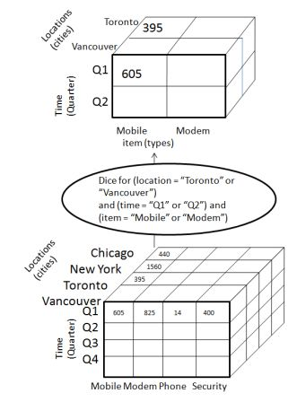

The dice operation on the cube based on the following selection criteria involves three dimensions.

* (location = "Toronto" or "Vancouver")
* (time = "Q1" or "Q2")
* (item =" Mobile" or "Modem")

**Pivot**

The pivot operation is also known as rotation. It rotates the data axes in view in order to provide an alternative presentation of data. Consider the following diagram that shows the pivot operation.

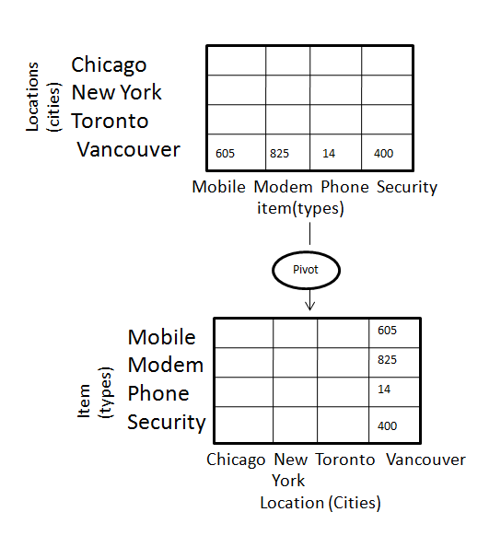

In this the item and location axes in 2-D slice are rotated.